Questionnaire for System Level Information

# System/Solution Overview

|  |  |
| --- | --- |
| **Name of System** | DTLMS(Distribution Transformer lifecycle Management software) |
| **Go Live Date (or Year)** | 2018 |

**OVERVIEW:**

Design, Development and implementation of Web based Distribution Transformer Lifecycle Management Software which includes

**KEY POINTS:**

* Generation of unique IDs for DTR and DTC.
* Capturing of distribution transformer failure report, proposal for Enhancing the capacity of DTR, generating Work Order, Indent, Invoice and Decommissioning.
* Manage the Failed DTRs.
* Declare the DTR as Scrap and action for further disposal.
* Track Maintenance details of the DTR based on the Maintenance Schedule defined.
* Tracking of movement of DTRs from store to repair center and back to store.

|  |  |  |
| --- | --- | --- |
| **Term/Acronym** | **Definition** | **Description** |
| BESC | BESCOM | Bangalore Electricity supply Company |
| DTLMS | DTLMS | DISTRIBUTION TRANSFORMER LIFECYCLE MANGEMENT SOFTWARE |

# System Actors

|  |  |  |
| --- | --- | --- |
| **User/Role** | **Frequency of Use** | **Approximate number of such users with this role** |
| AET - SDO | daily | 146 |
| AEE SDO | daily | 148 |
| EE-CO | daily | 7 |
| AAO | daily | 32 |
| BPA | daily | 15 |
| AAO SDO | daily | 9 |
| AO | daily | 32 |
| AET-DO | daily | 36 |
| STORE KEEPER | daily | 26 |
| AEE-CO | daily | 7 |
| SEE-CO | daily | 16 |
| SA-DO | daily | 21 |
| EE-DO | daily | 33 |
| AEE(O)-DO | daily | 32 |
| STO | daily | 22 |
| CASHIER | daily | 13 |
| MT | daily | 13 |
| AO(IA) | daily | 18 |
| CEE | daily | 5 |
| SECTION OFFICER | daily | 524 |
| GENERAL | daily | 44 |

1. System Architecture

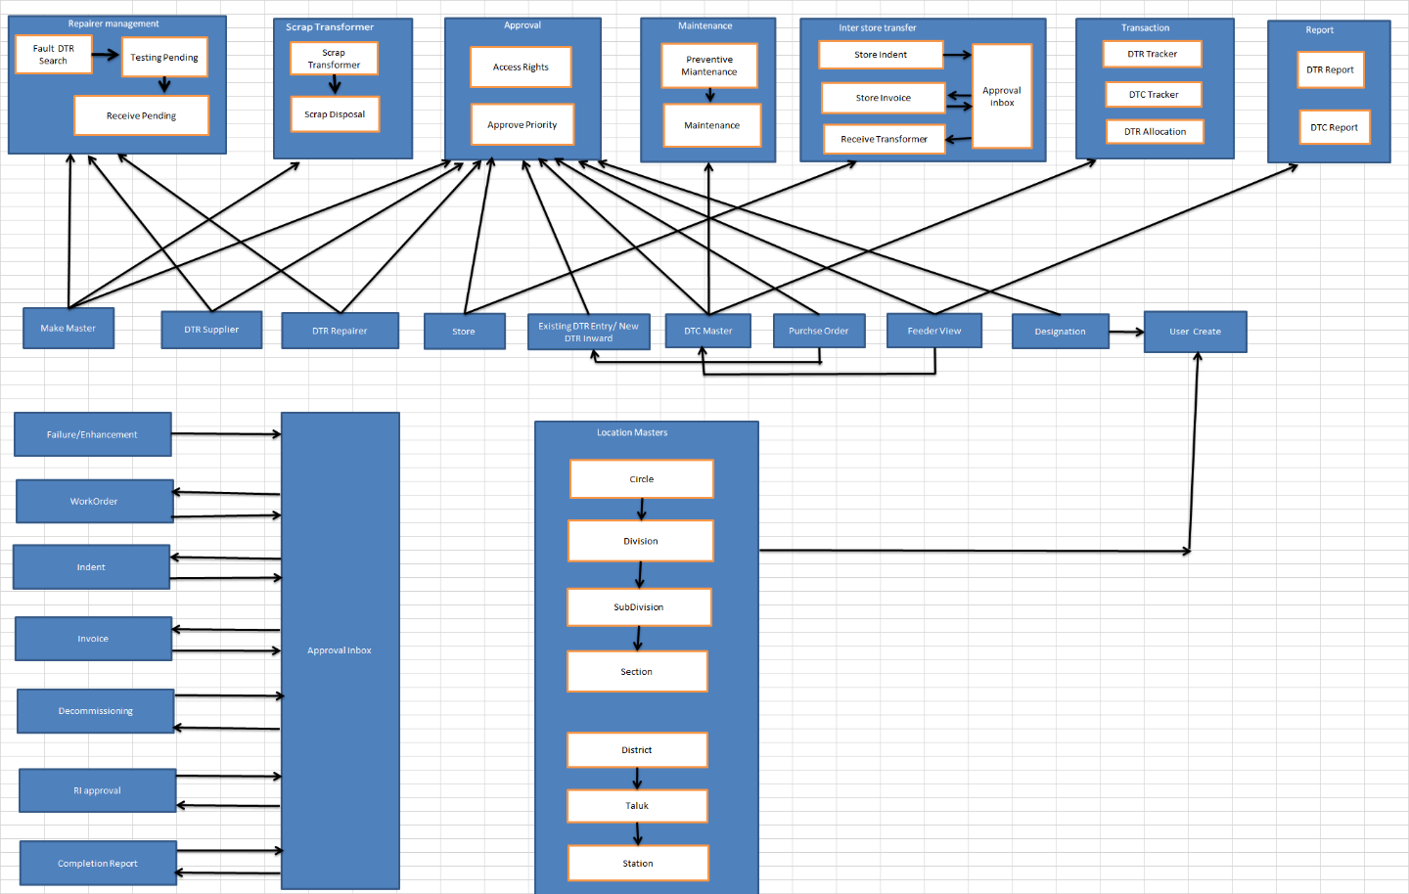

# Operating Environment

|  |  |  |  |
| --- | --- | --- | --- |
| **Software** | **Description** | **Version** | **Year of Procurement** |
| Windows server 2012r2 | Operating System for application Server | 2012r2 | 2018 |
| Window server 2012r2 | Operating System for Database Server | 2012r2 | 2018 |
| C# 4.5 | Language used for software development | 4.5 | 2018 |

|  |  |  |
| --- | --- | --- |
| **Hardware** | **Description** | **Year of Procurement** |
| Intel Xeon E5 2609v3 (Quad Core) Ivy Bridge  1.9 GHz  1900 MHz, 1x8GB Memory  1x300GB SAS HDD; 2.5" Hot Swap | HP ProLiant 180 Gen9 | 2018 |
| Multi Burner, Integrated RAID 01 in built  OS: Windows Server 2012 R2 64 Bit or higher. |  |  |
| TWO SOCKET RACK (2U)  Intel Xeon E5 2609v3 (Quad Core) Ivy Bridge  1.9 GHz  19000 MHz, 2x8GB Memory  1x300GB SAS HDD; 2.5" Hot Swap  Multi Burner, Integrated RAID 01 in built  OS: Windows Server 2012 R2 64 Bit or higher. | HP ProLiant 180 Gen9 | 2018 |

# External Interfaces and 3rd Party Dependencies

<List all required interfaces with anything external to this solution including hardware, software, external applications. External here means systems that are external to THIS system and not necessarily external to ESCOM >

|  |  |
| --- | --- |
| **Hardware Interface** | **Describe the Type of Interface/Dependency** |
| *<Hardware component>* | *<e.g., supported device types, the nature of the data and control interactions between the software and hardware>* |
|  |  |

|  |  |
| --- | --- |
| **Software Interface** | **Describe the Type of Interface/Dependency** |
| *<external applications, software components>* | *<e.g., Identify the data items or messages coming into and going out of the system>* |
|  |  |

|  |  |
| --- | --- |
| **Communication Interface** | **Describe the Type of Interface/Dependency** |
| *<identify any communications function required by this system>* | *<e.g., Identify any communication standards that are used, such as FTP or HTTP>* |
|  |  |

# Data Design

## Database Description

|  |  |  |  |
| --- | --- | --- | --- |
| **Database Name** | **Version** | **Total Amount of Storage/Number of records** | **Transaction Volume**  **(avg per day)** |
| Postgresql | 2.0 | Approx. cap 250 GB | Approx. 100 |
|  |  |  |  |

# Documentation Available

|  |  |  |
| --- | --- | --- |
| **Sr. No.** | **Document Name** | **Document Last Updated Date** |
| 1 | User Manual v1.7 | 31-05-2019 |
| 2 | Software Requirement Specific | 02-03-2016 |
| 3 | Detail Document | 15-02-2016 |
| 4 | DWA | 13-04-2016 |

# Logs and Audit Trails

|  |  |  |  |
| --- | --- | --- | --- |
| **Sr. No.** | **Name of the Log** | **Type (e.g. weblog)** | **Description (fields captured in the log entry)** |
| 1 | Exception Log | Text log | All exception logs pertained to web application are logged in a flat file |
| 2 | Login Activity Log | Web log | All login activity to web application are logged in a db. |
| 3 | Transaction Log | Web Log | All exception logs pertained to web application are logged in a flat file |

# Operational Metrics

|  |  |
| --- | --- |
| **Average number of logins per day during the last 30 days** | 60 |
| **Number of down times in the last 30 days** | 1*10=10 minutes(Derived) |
| **Peak number of concurrent users in the last 30 days** | 25 |